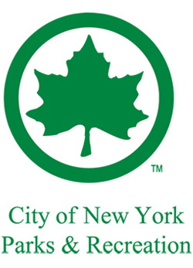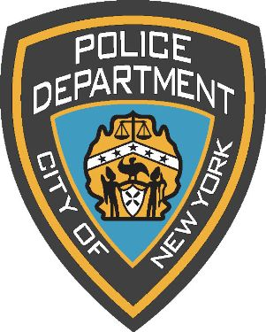

LITTLE BAY PARK
PARKING PERMIT
MARATHON RACE
7/23-24/2016
3:30 PM to 12:30 AM

